Semestral Project Manual: Full-Stack IoT System

I. Technical Specifications & Requirements

1. Hardware Specifications
- Microcontroller: ESP32 or ESP8266 development board.
- Sensors (Minimum 2): Any distinct ambient environment sensors (e.g., DHT11 Temperature, LDR Photoresistor, HC-SR501 PIR Motion).
- Actuators (Minimum 2): Any distinct controllable physical components (e.g., 5V Relay Channel, Active Buzzer, Servo Motor, LED Indicator).

2. Backend Server Specifications
- Framework: Laravel (Latest stable version).
- Database: MySQL or SQLite.
- API Protocol: RESTful JSON endpoints.

3. Mobile Client Specifications
- Framework: React Native (CLI or Expo framework).
- Target OS: Android.

II. System Architecture & Core Workflow
The system must operate using a centralized database architecture. Direct communication between the mobile device and the hardware is strictly prohibited.

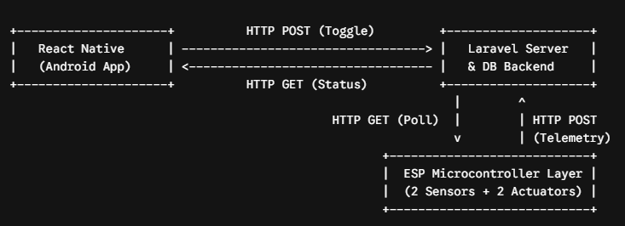

III. Phase-by-Phase Project Instructions

Phase 1: Hardware Firmware & Pin Configuration (ESP)
The microcontroller manages physical interactions, reading environmental inputs and driving mechanical or electrical outputs based on the server's state.
- Peripheral Pin Mapping: Wire the two chosen ambient sensors to appropriate input pins (analog or digital), and wire the two actuators to digital output pins on the microcontroller development board.
- Network Maintenance Loop: Configure the initialization routine to scan, authenticate, and maintain a stable connection with the local Wi-Fi access network.
- Telemetry Transmission Routine: Program a non-blocking loop that reads the physical sensors at fixed intervals, packages the raw electrical metrics into standard JSON formats, and transmits them to the server via web requests.
- Command Execution Routine: Implement a continuous web polling query every 1 to 2 seconds targeting the central server. Parse the server response and immediately modify the output voltage of the physical pins to trigger or kill the hardware actuators.

Phase 2: Database Schema, API Gateway & Admin Dashboard (Laravel)
The server operates as the central authority, hosting the data warehouse, exposing REST APIs, and providing a web-based administration view.

1. Database Schema & Migration Setup
- Telemetry Logs Table: Design a structural history log containing fields for the unique log ID, specific sensor type markers, decimal-capable reading columns, and automated creation timestamps.
- Actuator States Table: Design a live configuration status grid containing tracking rows for actuator identity, current operating states (boolean or variable integer markers), and tracking modification timestamps.

2. API Endpoint Protocols
- Sensor Ingestion Gateway: Expose an api-mapped endpoint that validates incoming telemetry streams from the hardware and appends them to the historical log database.
- Hardware Status Dispatcher: Expose a lightweight endpoint optimized for rapid hardware query cycles that yields only the active operational status values of the actuators.
- Mobile Command Target: Expose an endpoint that accepts incoming state modifications from client devices and alters database values instantly.

3. Web Admin Dashboard Features
- Authentication & Session Control: Require a secure username and password entry mask to access layout features. Enforce an inactivity logout tracker to safeguard active hardware panels.
- Real-Time Ecosystem Dashboard: Display a visual connection latency indicator that reads offline if the hardware stops pinging the system. Show clean data cards featuring the newest telemetry values alongside live state widgets for the actuators.
- Manual Overrides & Audit Controls: Build clickable web switches that bypass external applications to alter actuator database values instantly. Maintain a chronological event dashboard table showing the history of raw telemetry logs and system modifications.

Phase 3: Mobile Interface & Control Client (React Native)
The mobile application operates as the primary user-facing monitor and controller, translating network interactions into intuitive physical controls.
- Dynamic Target Configuration: Provide a configuration input grid allowing users to specify and modify the server gateway IP string at runtime. Cache this preference across app restarts.
- Real-Time Data Mirroring: Construct an interface mapping metrics from both sensors onto prominent tracking tiles. Execute automated background cycles every 3 seconds to fetch database updates from the server without freezing user controls.
- Dynamic Safety Alerting: Apply interface validation rules that colorize layout segments or flash warnings if incoming data values bypass normal operating constraints.
- Hardware Remote Controls: Implement interactive switch components mapped to the physical actuators. Enforce touch-lock buffering that freezes the switch interface when network updates are moving across the wire, blocking overlapping traffic.
- Bi-Directional State Synchronization: Ensure the on-screen mobile toggles automatically re-align their active positions if an administrator modifies the system state via the web-based backend console.

IV. Submission Deliverables & Deadlines

1. Final Deadline
Submission Date: End of the current month. Late submissions will automatically result in grade penalties.

2. Required Deliverables
Presentation Slides (PPT): A comprehensive PowerPoint presentation outlining the system architecture, database ERD schema, API endpoints design, network flow models, and hardware circuit wiring diagram.
Demonstration Video: A separate, unedited video recording demonstrating the actual operational project. The video must show real-time changes across the ecosystem (e.g., triggering a toggle on the React Native mobile app or the Web Dashboard, and showing the physical hardware actuator reacting to the change on camera).

